AIML 1 - Agents 2 - 27/02/23

***How to program an Agent?***

* **Table-driven Agent** (TDA)

This is deemed practically infeasible

* **Simple reflex Agent** (SRA)

SRAs are “the starter agent”, really simple and acting on the *current* percept, ignoring the past stimuli

*e.g.* Simple automated vacuum cleaner -> its decision to clean is based solely on its current location

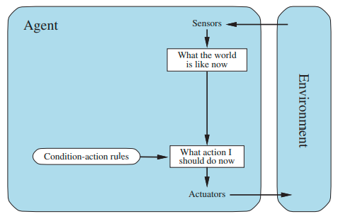

* **Model-based reflex Agent** (MBRA)

This kind of agent maintains some sort of internal state depending on percept history

*Changes*. These can be agent-dependent or agent-independent, and can be summarized in the term **Transition model**

*The effect of changes.* Defined in the **Sensor model**

These two allow the definition of the **Model-based Agent** to exist

* **Goal-based Agent** (GBA)

The notion of GBA comes from the fact that *it’s often NOT enough to rely on the current state,* therefore introducing the notion of **goal**

A goal is an objective that the agent has and pursues (by searching and planning)

*Parallelism between reflex and goal* (AIMA, pg. 72)

The reflex agent brakes when it sees brake lights, period. **It has no idea why**.

A goal-based agent brakes when it sees brake lights because **that’s the only action that it predicts will achieve its goal of not hitting other cars.**

* **Utility-based Agent** (UBA)

UBAs are a subclass of GBA